**System Analysis**

4.**1 Study of Current System**

**4.2 Problem and Weaknesses of Current System**

**4.3 .Requirements of New System**

**4.3.1 Functional Requirements**

**4.3.2 Non Functional Requirements**

**4.4 Feasibility Study**

**4.4.1 Does the system contribute to the overall objectives of the organization?**

* + 1. **Can the system be implemented using the current technology and within the given cost and schedule constraints?**
    2. **Can the system be integrated with other system which are already in place?**
  1. **Activity/Process In New System(Use event table)**
  2. **Features Of New System**

**For Conventional Approach (If you are following Procedural Design)**

* 1. **Functions Of System**
  2. **Context Diagram**

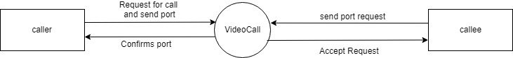

* 1. **List Main Modules Of New System**
  2. **Selection Of Hardware and Software and Justification**